1. In last lecture, we created our route with **dynamic path segment**.
2. **Agenda**: Now we want to access the data that user sends to us or which is encoded in the URL.
3. 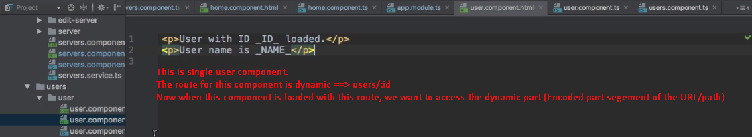
4. The currently loaded route is JS object with a lot of metadata about this currently loaded route. One of these important pieces of information is the currently active user. 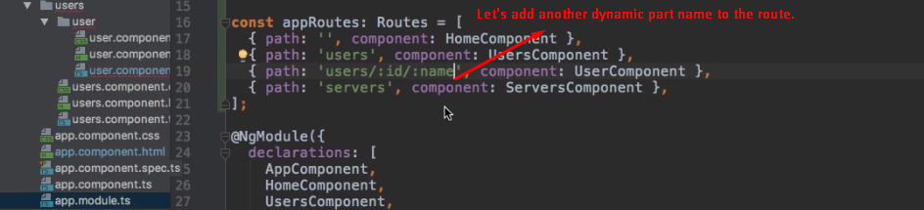
5. 
6. 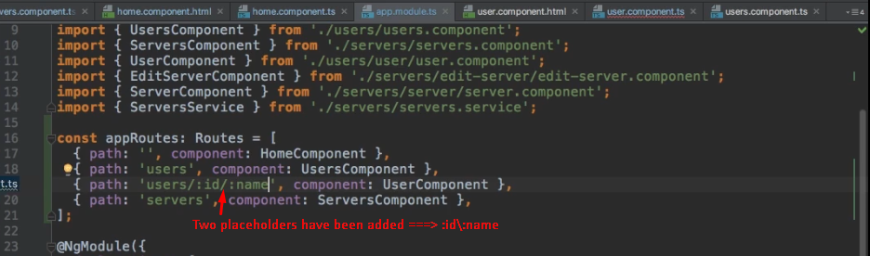
7. 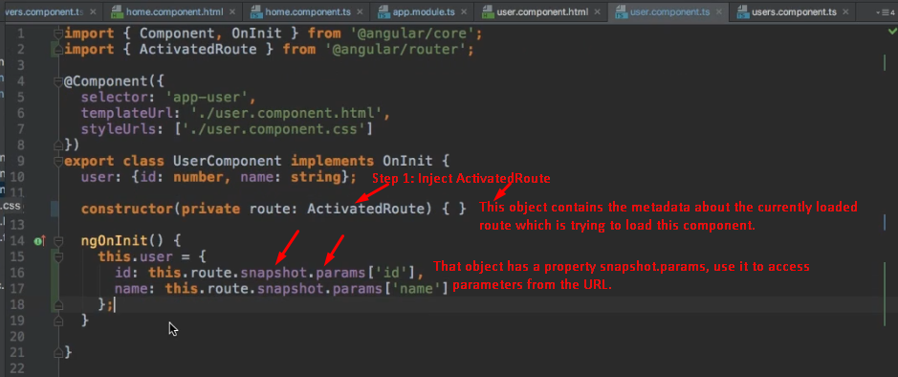
8. 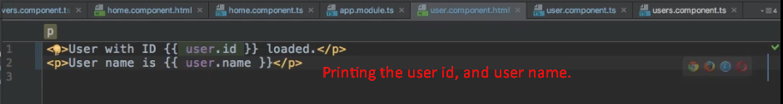
9. 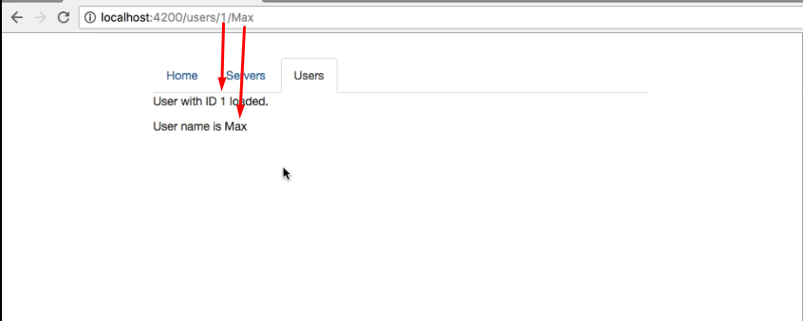
10. 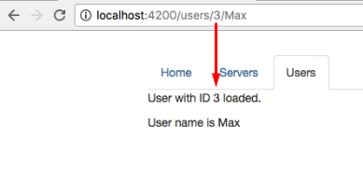
11. 